# CS 340 README Stephan

## About the Project/Project Title

This Python program provides functionalities to interact with a MongoDB database and perform CRUD operations. It allows you to connect to a MongoDB server, access a specific database, and perform various operations like inserting, querying, updating, and deleting documents.

## Motivation

The reason for this project is to create a learning environment for students. It is a good example of creating code that is useful to interact with noSQL databases and provides code for reusability and consistency moving forward with projects.

## Getting Started

To get started, add the .py module with the base code and credentials to the working directory or a location you can access. Once there import the AnimalShelterCRUD class.

## Installation

Once the class is imported it is important to have the other needed libraries. pyMongo and bson.objectid need to be in the environment.

## Usage

In order to use this product you need to ensure you have a user within the desired database with the required rights. The current code uses database “AAC” and user “aacuser” If you have other users it may need to be modified.

### Code Example

Create() - The create function adds a document to the animals collection. It takes a dictionary item and adds it as a new document. on success it will return ‘inserted’

document = {"name":"document insert test","content":"Let's see if this works"}

dbinstance.create(document)

Read() - The read function takes a key-value pair and completes a find() query within the animals collection. The return will be the result of the query.

key = {"name":"document insert test"}

print(dbinstance.read(key))

Update() - this function updates documents that match the key provided. Will return number of changed documents

new_content = {"content":"updated content"}

print(dbinstance.update(key,new_content))

Delete() - will delete documents that match input data. returns number of deleted items

print(dbinstance.delete(key))

### Screenshots

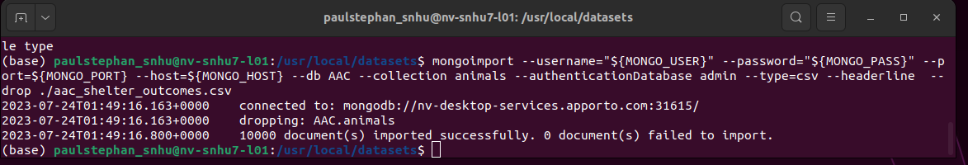

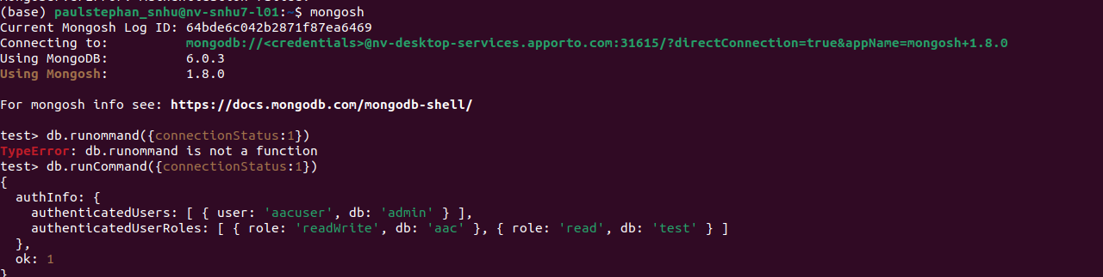

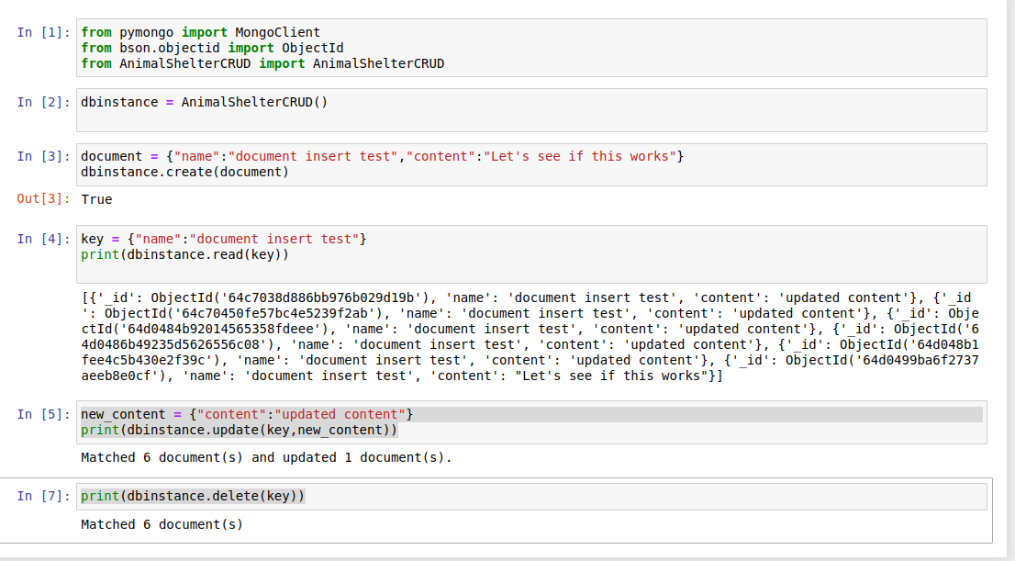

## Roadmap/Features (Optional)

No updates planned in the immediate future

## Contact

Your name: Paul Stephan